5 B u n a a n C l o s e
W r e c k b a y v i l l a g e , j e r v i s b a y
P h o n e : 0 2 4 4 4 2 1 0 2 9
I N D I G E N O U S SP O R T S G R A N T P R O G R A M ( I S G P )
Funding for the Indigenous Sports Grants Program (ISGP) is provided to the
Wreck Bay Aboriginal Community Council through the Department of the Prime Minister and Cabinet’s (DPM&C) Indigenous Advancement Strategy (IAS).
The ISGP supports the IAS’ Safety and Wellbeing Programme by providing assistance to Indigenous Australians to enjoy similar levels of physical, emotional and social wellbeing enjoyed by other Australians by fostering the ability of Aboriginal and Torres Strait Islander peoples to engage in education, employment and other opportunities.
The ISGP is administered by Wreck Bay Aboriginal Community Council. The funding provided through the ISGP is limited and as such, all applications will need to adhere strictly to the compliance criteria. Funding will continue to be available until exhausted. It is possible that not all requests for assistance will be approved, therefore funding should not be deemed automatic or anticipated.

Applicants of all ages are eligible to apply for funding through the ISGP, except for applicants of the Individual Representative Grant who must be 12 years or older. However applications for applicants aged 17 years or younger will need to be completed by the applicant’s parent or guardian.

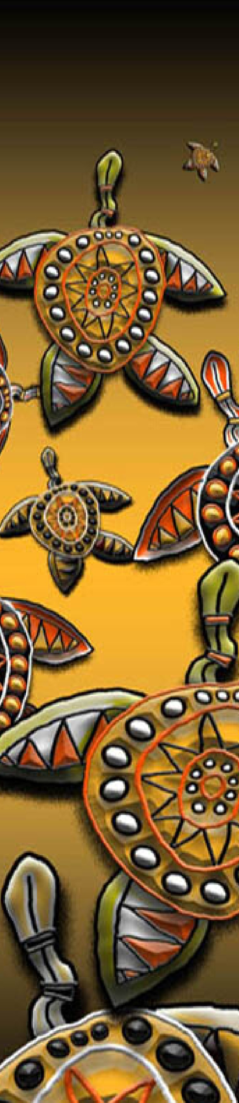
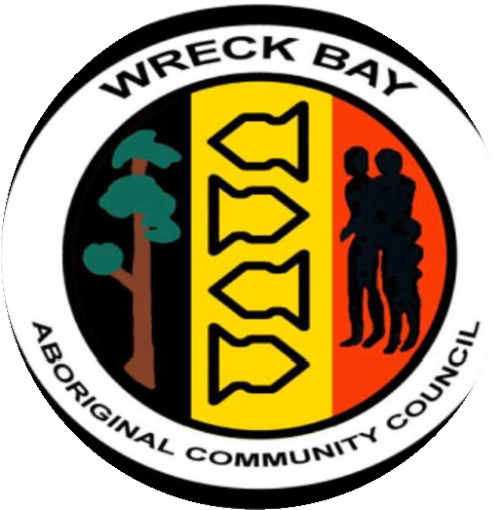
Eligible - Individual Sports and Active Recreation Grant -Formal sports or active recreation competitions and programs of at least 6 weeks in duration.

P
R
O
F
E
S
S
I
O
N
A
L
S
K
I
L
L
S
Eligible - Individual Education and Training Grant - Education and training courses/workshops that relate directly to organised sport or active recreation
.
Eligible - Individual Representative Grant - Applicants must be participating as an athlete, coach, manager or official in: An official national championship endorsed by the relevant ASC recognised national sporting organization (NSO) or School Sport Australia (SSA); or An international competition as a member of an official Australian team endorsed by an ASC recognised NSO or SSA.
Types of Grants: three types of grants are available to eligible people:

Individual Sports and Active Recreation Grant
An individual can apply for up to $200 to support their participation in an organised sports or active recreation competition or program of at least 6 weeks in duration.

Individual Education and Training Grant
An individual can apply for up to $200 to support their participation in an education and training opportunity that relates directly to organised sport or active recreation.
Individual Representative Grant
An individual can apply for up to $200 to support their participation in a representative sporting opportunity.

