WRECK BAY ABORIGINAL COMMUNITY COUNCIL
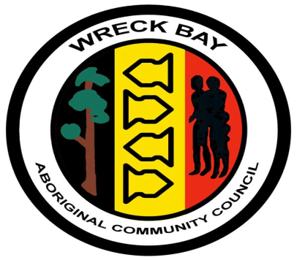

POLICY DOCUMENT
Dated 13 November 2018
COMMUNITY SUPPORT PROGRAM – HIGHER EDUCATION SCHOLARSHIP POLICY
Wreck Bay Aboriginal Community Council is committed to encouraging all community members to develop themselves academically, in order to be able to effectively meet the challenges of changing needs, improve educational outcomes for indigenous students and contribute to the advancement of the Wreck Bay Aboriginal Community.
The Higher Education Scholarship is administered by Council and aims to support students connected to the Wreck Bay Aboriginal Community to undertake accredited tertiary education programs.
The Scholarships:
Four Higher Education Scholarships of up to $3000 for each student may be awarded to any student who will commence full-time or part time study in the next academic year OR continues undertaking a specific course of full-time or part time study in subsequent years; with such study being undertaken at a recognised tertiary institution. The Scholarship is available to students who have completed one course of study and wish to extend their education with higher level studies (eg. a graduate diploma or a master’s degree). Students who are beginning or extending their study in an area providing particular benefit to indigenous communities will be considered favourably in the application process.
The award of $3000 shall be paid in three yearly instalments of $1000 each, at or immediately prior to the commencement of each year of the course. If the course is an extension course and is for a period less than three years, the scholarship will be pro-rated based on the length of the course and will be payable as a single instalment prior to commencement of the course.
The CEO is responsible for assessing applications and deciding whether a Higher Education Scholarship will be approved and provided. The CEO’s decision on a Higher Education scholarship is final.
Eligibility:
The applicant must be a registered member or a dependent child of a registered member providing such dependent child is under the age of 21 years at the time of applying for the scholarship.
Applicants who have applied for or who may receive other scholarships or awards are eligible to apply for a Higher Education Scholarship.
Application Process:
Each applicant must complete the attached Application Form and provide the following documentation:
A statement from the applicant addressing the eligibility criteria, stating the claims against the selection criteria and a letter of acceptance/notification from the tertiary institution of acceptance of the applicant to attend a full time or part time course.

This policy is to be reviewed yearly.
Next review date 13 November 2019

